*The Synxis Booking Engine (SBE) has an average response time of 2 seconds for each transaction. If you are experiencing delays in the performance or response times for any reason, please use the below instructions to document the response times using a HAR file extraction and then submit a ticket to SHS Customer Care* [*shscustomercare@sabre.com*](mailto:shscustomercare@sabre.com) *with the results as an attachment to the ticket.*

1. Open Google Chrome and navigate to the page where the issue is occurring
2. From the Chrome menu bar select Options > More Tools > Developer Tools or press F12 key on your keyboard:

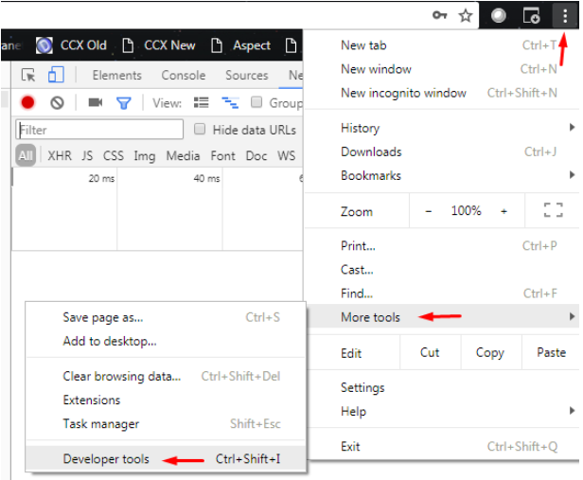

1. Once the panel opens, select the "Network" tab.
2. Look for a red circle "Record button" in the upper left corner of the Network tab, and make sure it is red. If it is grey, click it once to start recording:

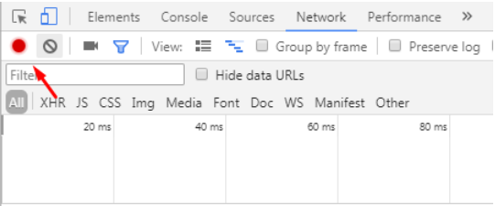

1. Check the "Preserve log" box.
2. Click the "Clear" button (next to record button) to clear out any existing logs from the Network tab:

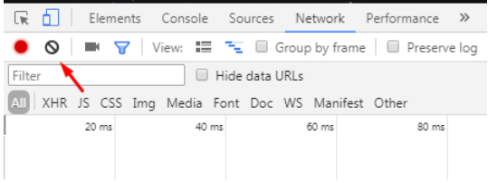

1. Now try to reproduce the issue that you were experiencing before, while the network requests are being recorded.
2. Once you have reproduced the issue, right click anywhere on the grid of network requests, select "Save as HAR with Content", and make sure you save the file in your computer:

